**Desarrollo taller Fase 3**

1. Realice la sustitución diatónica del siguiente enlace armónico y luego armonice a 4 voces en escritura coral.
2. Realice un análisis armónico (cifrado americano y analítico) del

siguiente ejercicio coral escrito a 4 voces en escritura de teclado.

*Tonalidad inicial: Bb*

*Tonalidad final: Gm*

*Tipo de modulación:*

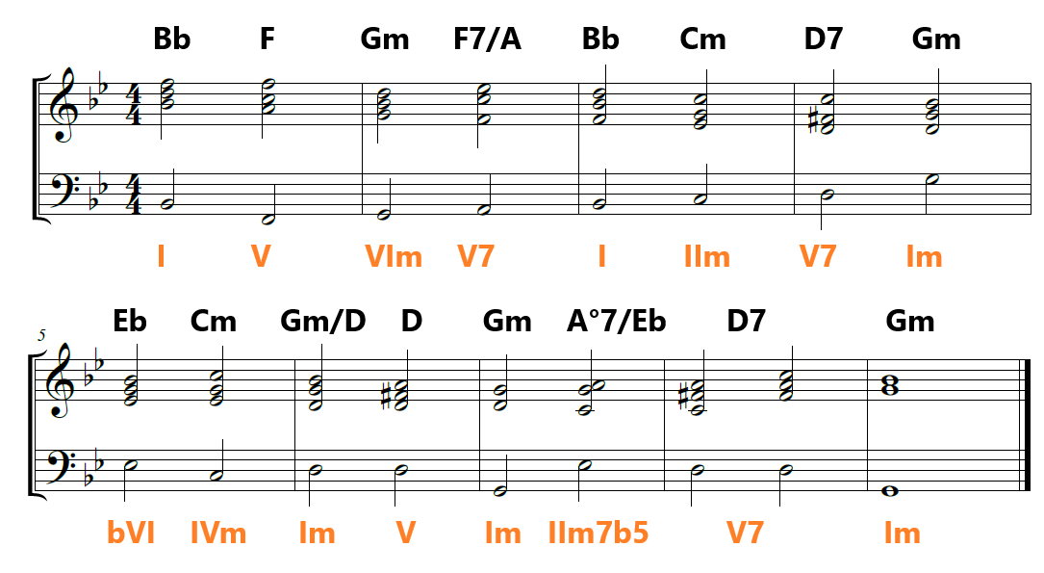

|  |  |  |  |  |  |  |  |
| --- | --- | --- | --- | --- | --- | --- | --- |
|  | I, Im | IIm, II° | IIIm, bIII | IV, IVm | V | VIm, bVI | VII°, bVII |
| Sol Mayor | G, Gm | Am, A° | Bm, Bb | C, Cm | D | Em, Eb | F#°, F |
| Si Mayor | B, Bm | C#m, C#° | D#m, D | E, Em | F# | G#m, G | A#°, A |
| Mi Mayor | E, Em | F#m, F#° | G#m, G | A, Am | B | C#m, C | D#°, D |
| Lab Mayor | Ab, Abm | Bbm, Bb° | Cm, Cb | Db, Dbm | Eb | Fm, Fb | G°, Gb |
| Fa Mayor | F, Fm | Gm, G° | Am, Ab | Bb, Bbm | C | Dm, Db | E°, Eb |
| Do# Mayor | C#, C#m | D#m, D#° | E#m, E | F#, F#m | G# | A#m, A | B#°, B |